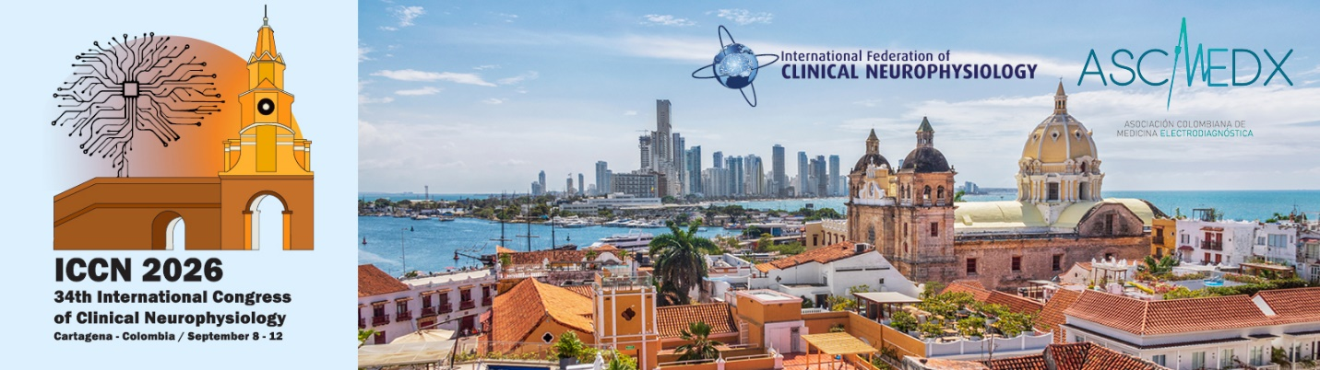 Speaker and Moderator
34th International Congress of Clinical Neurophysiology – ICCN 2026

Handbook

September 8-12, 2026
Centro de Convenciones Cartagena de Indias Convention Center (CCCI)
Cartagena, Colombia

Table of Contents

Welcome 2
Important Moderator & Speaker Due Dates 3
Speaker Acceptance Procedure 5
• Pre-Congress and/or Spanish Track (only 5
• Congress Symposia Speaker 5
• Pre-Congress and Congress Speaker 6
AV/Supplies/Equipment - Request Form 7
IFCN Membership 8
Speaker Slide Template & Tips While Preparing 8
Gala Dinner 9
CME & CEU Information 10
Congress Symposia Speaker Honorarium 11
Honorarium for International Symposia Speakers 11
Speaker Travel Tips & Reminders 12
Travel Reimbursement 12
Flight Travel Tips 12
Airport Information 12
Travel Documentation and VISAs 12
Onsite AV Logistics Upon Arrival at the Congress 13
Session Timing-Day of Event 13
Presentation Best Practice Tips 13
Additional Tips 13
Housing and Travel Arrangements 14
Moderator Tips for Organizing and Preparing Sessions 15
Speaker Forms – Summary Review 15

Welcome
Dear ICCN Speaker,
Welcome, and thank you for joining us as a speaker and/or moderator for the 34th International Congress of Clinical Neurophysiology (ICCN 2026) taking place September 8-12, 2026, at the Centro de Convenciones Cartagena de Indias Convention Center in Cartagena (CCCI), Colombia. We are delighted to have you share your expertise and insights with our attendees on site.
Your contribution plays an important role in shaping an engaging and memorable program. This handbook includes important details to help you prepare for your participation as a Moderator and/or Speaker. Please review the materials carefully and return the appropriate forms by the dates listed below to accept and confirm your participation.
We are committed to making your Congress experience enjoyable and seamless. Please utilize the FourWaves software link which after you provide your information will be your go-to source for your session date, time, and room assignment(s), audiovisual arrangements, and registration details. Should you have any questions, please contact Kathy Uy, MS CMP – ICCN Senior Meetings Manager at kuy@ifcninfo or +1 262.366.3810 on WhatsApp.
Once again, thank you for being part of ICCN 2026. We look forward to your presentation and to welcoming you to Cartagena, Colombia in September!
With appreciation,
Jorge Gutierrez and Hatice Tankisi
ICCN 2026 Scientific Committee Co-Moderators
Scientific Committee of International Congress (SC) Members:  Ambra Stefani, Sleep Neurophysiology and Sleep Science  Aysegul Gunduz, Brainstem  Caterina Leone, PAINterest  Claudio Babiloni, Adv EEG-MEG Techniques  Edicson Ruiz, PM&R Chief, Dept at the Uni Nacional in Bogotá  Lisa D Hobson-Webb, IFCN Society of Neuromuscular Imaging  Margitta Seeck, Editor in Chief, Clinical Neurophysiology Practice Journal  Robert Chen, Editor in Chief, Clinical Neurophysiology Journal  Ulf Ziemann, Brain Stimulation  IFCN Staff  Kathy Uy, Senior Meeting Planner  Kay Whalen, IFCN Secretariat  Kim Zaiss, Executive Director | Organizing Committee of International Congresses (OCIC) Members  Jonathan Cole – IFCN President/Moderator of OCIC  Aatif Husain – IFCN Treasurer/co-Congress Treasurer  Jorge Gutierrez – IFCN Secretary/Congress Scientific Committee co-Chair  Walter Paulus – IFCN Past-President  Andrea Giraldo – Congress Secretary  Carlos Rangel – Congress Convenor/AMCE President  Enrique Estevez – Moderator of Congress Local Organising Committee  Hatice Tankisi – Congress Scientific Committee co-Moderator  Margitta Seeck – Editor-in-Chief, Clinical Neurophysiology Practice  Robert Chen – Editor-in-Chief, Clinical Neurophysiology  Salomon Abuchalbe – Congress Treasurer

Important Moderator & Speaker Due Dates
Moderator and Speaker Timeline - Due Date | Item  *dates and items may change, please check back regularly
- Tuesday, January 20, 2026 | Speaker Acceptance DUE: Speakers must accept and confirm in-person attendance at ICCN 2026.  * Periodic reminders will be sent as the date approaches to those who have not yet completed this task.  - Speakers who do not respond by this date will have their invitation withdrawn. The next speaker on the waitlist will then be invited.
- May 1 | Moderators: Moderators must submit Audiovisual and Equipment Request Forms to IFCN Headquarters (one form per session, not per speaker). The Moderator should review all audiovisual and equipment requirements and share them with IFCN. Any requests for items not listed below must be confirmed with IFCN Headquarters in advance.  • Meeting rooms include screen, projector, laptop, podium w/mic, laser pointer, speaker table for 3-4 w/table mic.  • Plenary/Lecture/General Assembly room includes stage, podium w/ mic, two large screens  Speakers: Please note reliable internet is not available onsite-please download your presentation (and any links/videos) and provide to the Speaker Ready Room onsite.
- June 8 | Hotel Cut-off / Early Bird Registration Cut-off: Speakers are advised to book their hotel accommodation at the venue of their choice by this date. It is also recommended to finalize your flight arrangements.  Periodic reminders will be sent as the date approaches to those who have not yet completed this task.
- June 30 | Deadline to update session content for the final program.  Licensing Permission Agreement and Release Form must be submitted to IFCN Headquarters.  Final course and session descriptions, together with speaker affiliations and contact information, are due by June 30.  Moderators may review existing session and course information on the ICCN 2026 FourWaves website.
- Moderator and Speaker Timeline - Due Date | Item - continued
- August 1 -31 | • Prepare your slides (in PowerPoint). For best results, use the link provided on the website to upload prior to arriving at the Congress. Upload slides to the link provided (will be available in August)
- September 8-12 | 34th International Congress of Clinical Neurophysiology (ICCN 2026) Cartagena, Colombia  - Tuesday and Wednesday are pre-Congress sessions which will cover fundamental education and recent scientific advancements in central and peripheral clinical neurophysiology and include workshops and teaching courses.  - The three-day Congress (Thursday-Saturday) will include plenary lectures and symposia. Educational sessions on Saturday will conclude at 1:00pm.
- October 12, 2026 | IFCN will disburse travel Honorariums to eligible speakers who have attended and presented at the ICCN, once their Speaker Travel Honorarium Request has been submitted.
- December 8, 2026 | Final deadline to submit Speaker Travel Honorarium Requests for speakers who attended ICCN 2026.

Speaker Acceptance Procedure
We are pleased to invite you to speak at ICCN 2026. To accept this invitation, each speaker must complete their own registration by following the instructions below. Speakers are required to accept or decline the invitation no later than January 20, 2026 – see the required steps below.
There are three categories of speaker invitations. Please review your invitation(s) carefully to understand the specific benefits associated with each. As each session constitutes a separate invitation, you may receive multiple invitations.
- Pre-Congress and/or Spanish Track (only): Invited Pre-Congress and/or Spanish Track Speakers will receive complimentary registration for your assigned Education Course. Fees for additional Education Courses and/or for Congress attendance are not waived and must be paid during the registration process. Please register on your own to attend the Congress. If you wish to decline the speaker invitation, please forward your invitation to Kathy at kuy@ifcn.info and denote the reason so we may share with the planning committee.
Action Steps to ACCEPT Pre-Congress and/or Spanish Track Invitation: DUE: January 20, 2026
- Accept Speaker Invitation: https://event.fourwaves.com/iccn2026/registration
- Submit disclosure: https://disclosure.amedcoedu.com/events/8569
- Register for Congress: https://iccn.ifcn.info/registration/register-for-iccn
- Speakers are required to complete each of these steps by January 20, 2026 to formally accept the invitation.
  - Periodic reminders will be issued to individuals who have not yet completed these tasks as the deadline approaches.
- Congress Symposia Speaker: In appreciation of your participation as a Congress symposia speaker, you will receive complimentary registration for the Congress. By accepting the invitation and submitting the form on the Speaker Management Portal, you will be automatically enrolled/registered as an attendee for ICCN 2026.
  - The Speaker Congress registration fee includes access to the Symposia sessions from Sept. 10 through Sept. 12, the Welcome Reception and Ceremony, the Opening Ceremony and Award Lectures, Lunch and Posters on Wednesday through Saturday, coffee breaks, and the Awards and Closing Ceremony. To accept the invitation to speak at ICCN, click on Accept Speaker Invitation link below:

Action Steps to ACCEPT Congress Symposia Invitation: DUE: January 20, 2026
- Accept Speaker Invitation: https://event.fourwaves.com/iccn2026/registration
- Submit disclosure: https://disclosure.amedcoedu.com/events/8569
- You are eligible for an honorarium. Please Submit a W8 (for Speakers outside of the United States) or W9 (for Speakers within the United States) Please forward completed form to this secure site:  ICCN 2026 - SPEAKERS. See the Honorarium section below for more information.
- (Optional) Register for Pre-Congress/Gala Dinner tickets: https://iccn.ifcn.info/registration/register-for-iccn
- If you wish to decline the Congress symposia invitation, please forward your invitation to Kathy at kuy@ifcn.info and denote the reason so we may share with the planning committee.
- Speakers are required to complete each of these steps by January 20, 2026 to formally accept the invitation.
  - Periodic reminders will be issued to individuals who have not yet completed these tasks as the deadline approaches.
- Pre-Congress and Symposia Congress Speaker: In appreciation of your participation as a Pre-Congress and Symposia Congress speaker, you will receive complimentary registration for the Congress and the Pre-Congress course you are instructing. By accepting the invitation and submitting the form on the Speaker Management Portal, you will be automatically enrolled as an attendee for ICCN 2026.
* The Speaker Symposia Congress registration fee includes access to the Symposia sessions from Sept. 10 through Sept. 12, the Welcome Reception and Ceremony, the Opening
Ceremony and Award Lectures, Lunch and Posters on Wednesday through Saturday, coffee breaks, and the Awards and Closing Ceremony.
To accept the invitation to speak at ICCN, click on Accept Speaker Invitation link below:
Action Steps to ACCEPT Pre-Congress and Congress Invitation: DUE: January 20, 2026
- Accept Speaker Invitation: https://event.fourwaves.com/iccn2026/registration
- Submit disclosure: https://disclosure.amedcoedu.com/events/8569
- You are eligible for an honorarium. Please Submit a W8 (for Speakers outside of the United States) or W9 (for Speakers within the United States) Please forward completed form to this secure site: ICCN 2026 - SPEAKERS. See the Honorarium section (p.11) for more information.
- (Optional) Register for other Pre-Congress or Gala Dinner Tickets: https://iccn.ifcn.info/registration/register-for-iccn
- If you wish to decline the invitation, please forward your invitation to Kathy at kuy@ifcn.info and denote the reason so we may share with the planning committee.
- Speakers are required to complete each of these steps by January 20, 2026 to formally accept the invitation.
  - Periodic reminders will be issued to individuals who have not yet completed these tasks as the deadline approaches.
More Information: Additional speaker information is located on the ICCN 2026 website under Programme > Speakers or https://iccn.ifcn.info/programme/speaker-information. Speakers will receive an email confirmation once registered. The meeting badge and the speaker ribbon can be picked up onsite from the Registration Desk when you arrive in Cartagena.
Once registered for the congress, you may add optional items—such as Gala Dinner tickets or Pre‑Congress courses—through the Attendee platform.
Would you like to attend the Pre-Congress sessions and/or the Gala Dinner? Please note that additional fees apply for the Education and Pre-Congress Courses scheduled on Tuesday, September 8 and Wednesday, September 9, as well as for the Gala Dinner on Friday, September 11. Participation in these events requires a separate registration form and payment. See the link below to register and provide payment:
ADD PRE-CONGRESS REGISTRATION AND/OR GALA TICKET
https://iccn.ifcn.info/registration/register-for-iccn
If you have questions and/or challenges, please contact Kathy Uy, MS CMP – IFCN Senior Meetings Manager at kuy@ifcn.info.

AV/Supplies/Equipment - Request Form
Moderators are responsible for communicating supplies needed for their session to the IFCN headquarters. The room request document provides a checklist of preparations and answers many common presenter questions for before, during, and after the Congress, including AV setup in each room, course material deadlines, shipping details, storage, and more.
- Pre-Congress Meeting rooms include screen, projector, laptop, podium w/mic, laser pointer, speaker table for 3-4 w/table mic and classroom seating.
- Symposia Meeting rooms include screen, projector, laptop, podium w/mic, laser pointer, speaker table for 3-4 w/table mic and theatre seating
- Plenary/Lecture/General Assembly room includes stage, podium w/ mic, two large screens and theatre seating.
If you wish to suggest an alternate set up and/or will need equipment (i.e. lab set up), please use this form below to specify the change(s). This form is due May 1, 2026.
AV and Equipment Request Form
https://forms.gle/tFhbWAzJ8qA9P5Br7

IFCN Membership
Are you an IFCN member? We encourage eligible speakers and moderators to join or renew their membership through their local IFCN society. By becoming part of the International Federation of Clinical Neurophysiology (IFCN), which includes member societies in 69 countries, you gain access to a global community committed to advancing excellence in clinical neurophysiology. IFCN’s mission is to promote best practices worldwide through education and research. Your membership strengthens this collective effort and supports your own professional growth. For more information, please see IFCN Membership.
Join/Renew IFCN Society Membership

Speaker Slide Template
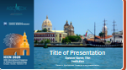
The ICCN 2026 PowerPoint template is available on the Speaker Information page as a download. Using the template helps keep presentations consistent. Its use is recommended, but not required.
If you add your organization or institutional logo, it may appear only on the first slide. IFCN asks all speakers to include a Conflict of Interest (COI) disclosure on their opening slide.
Download Speaker Slide Template
https://iccn.ifcn.info/programme/speaker-information

Speakers - How to Prepare
Speakers are asked to upload and bring their presentation on a flash drive in 16:9 format, prepared in PowerPoint or Keynote.
* Symposia Speakers: A link to upload your presentation in advance of the Congress will be provided in August.
* Pre-Congress and ELATAM Speakers: You will bring your flash drive or laptop directly to your session room - you will be using your laptop or sharing your slides via a flash drive on the course director's laptop.
* Please bring any embedded files as separate, individual files along with your presentation. Meet with the technician onsite to discuss how to best use embedded files during your presentation.
* Wi-Fi will not be available for speakers to access online content during their Congress presentation.
* Speakers are respectfully asked to stay within their allotted scheduled time; session moderators will conclude any presentation that exceeds the limit. See the Program Schedule to confirm the date, time, room and other session information.
CONFIRMING SLIDE RECEIPT
*While onsite, symposia speakers are strongly encouraged to visit the Speaker Ready Room by 5:00 p.m. the day BEFORE their scheduled session to review their slides, make any edits, and confirm formatting.
* Please note: Technicians in the symposia session rooms cannot accept late or updated slides immediately prior to the speaker's presentation. All Symposia presentations must be submitted through the Speaker Ready Room in advance.

Gala Dinner
ICCN's Gala is the premier social event of the Congress where guests can network and forge new relationships in a lively, communal setting. At the Gala, plan to connect with inspiring leaders, engaging colleagues and have some fun on the dance floor! Join your colleagues for an unforgettable evening. Speakers will have the option to add a ticket for themselves and one guest to attend the Gala Reception on Friday, September 11 as a part of their registration. The Gala Dinner is a ticketed event, and a limited number of tickets are available. To order Gala Dinner ticket(s), submit the registration form on the link below:
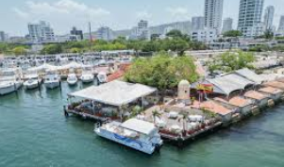
ADD GALA TICKET
https://iccn.ifcn.info/registration/register-for-iccn

CME & CEU Information
ICCN 2026 is designed to provide a solid review of the fundamentals and the latest scientific advances in both central and peripheral clinical neurophysiology. Presentations will be given by leading experts in the field and have value for health care professionals who utilize clinical neurophysiology. Sessions include symposia, workshops, courses and Special Interest Groups, featuring didactic lectures, expert panels, debates and interactive formats. Poster presentations will highlight the latest work conducted at clinical neurophysiology centers around the globe.
Target Audience: The ICCN 2026 educational activities are directed to clinical neurophysiologists, neurologists, psychiatrists, physiatrists, neurosurgeons, trainees in these disciplines and other physicians and researchers who utilize clinical neurophysiological techniques and knowledge in the diagnosis and management of patients with disorders of the nervous system.
Accreditation Statement: ICCN 2026 is accredited by Amedco to provide American (ACCME) and European (EMEAC) continuing medical education for physicians. Credit Designation: <coming soon>
Physicians should claim only credit commensurate with the extent of their participation in the activity.

Congress Symposia Speaker Honorarium
Invited Congress Symposia speakers will receive free registration for the ICCN Congress and an honorarium, based on their location, to assist with travel expenses. Travel and accommodation costs are the responsibility of the speaker. Pre-Congress and Spanish track speakers are not eligible for an honorarium.
Speakers are encouraged to ask their institution about honorarium or funding opportunities to help cover meeting expenses.

Honorarium for International Symposia Speakers
The Organizing Committee for ICCN has approved the following honorarium amounts for invited symposia speakers: (in USD)
- $300 Colombia
- $800 Latin America
- $1,000 Europe, Middle East, Africa
- $900 United States, Canada
- $1,100 Asia Oceanic
To ensure equity across our global community, honoraria for international congress attendees are determined using the World Bank’s country income classifications. This tiered model recognizes differences in economic conditions, cost of living, and currency values, allowing us to provide a fair and balanced scale. Please note that the World Health Organization (WHO) does not maintain its own income classifications; instead, it relies on the World Bank’s data for these distinctions. This tiered honorarium approach helps maximize participation by making the congress more accessible worldwide.
To request an honorarium, the Symposia speaker is required to submit the Wire Transfer Request form (and a Form W8 or W9 which were due January 20, 2026) after the Congress and by December 8, 2026.
In order to receive the ICCN honorarium, speakers will need to submit a
- W8 (for speakers outside of the United States) or
- W9 (for speakers within the United States and their bank information.
- ICCN 2026 Speaker wire transfer form
Honorariums are processed within 30 days upon receipt and must be submitted to IFCN by December 8, 2026.
If you have questions or would like more information, please contact us at info@ifcn.info

Speaker Travel Tips & Reminders
We look forward to welcoming you to ICCN 2026. After registering for the Congress, you’ll want to research and confirm your other travel arrangements. To help ensure a smooth and enjoyable experience, please review the following travel tips and reminders before your trip.

Travel Reimbursement
Speakers are encouraged to ask their institution about honorarium or funding opportunities to help cover meeting expenses. Travel and accommodation costs are the responsibility of the speaker.

Flight Travel Tips
- Book Early: Reserve your flights as soon as possible to secure the best rates and convenient schedules. Flight prices typically increase significantly in the final weeks and days before departure.
- Arrival: We recommend arriving at minimum, one day before your scheduled presentation. This allows time to adjust to any unforeseen travel delays, as well as to become familiar with the venue, local environment, and cultural setting. Planning ahead and anticipating possible flight disruptions will help ensure a stress-free experience and a successful presentation. Education sessions during the Congress will begin daily at 8am.
- Departure: The Congress will conclude on Saturday, September 12, at 2:00pm. We encourage attendees to remain for the entire program to gain the full benefit of session discussions and maximum CME credits.

Airport Information
The airport in Cartagena is the Rafael Núñez International Airport (CTG). The airport offers 47 direct international connections, flights from 26 countries, 24 airlines, and over 1,000 weekly flights from Bogotá to Cartagena.
Transportation to Hotels
Public transportation is not available to the hotels. Use the Uber app to request rides on-demand, schedule rides in advance, or request a local taxi. Other ride sharing apps like Cabify and DiDi are also available. It is best practice book your transfer in advance to help lock in a price and avoid surge pricing. See the ICCN website for more travel FAQs: https://iccn.ifcn.info/registration/registration-faqs

Travel Documentation and VISAs
Ensure your government-issued ID or passport is valid and that you have any required travel visas. See the ICCN website for more information: https://iccn.ifcn.info/registration/passports-visas.

Onsite AV Logistics Upon Arrival at the Congress
We recommend that speakers and moderators pick up their badge and registration materials promptly onsite when the ICCN Registration Desk opens.
To ensure everything runs smoothly, and there are no surprises, we encourage speakers to check in with the AV technician in the Speaker Ready Room no later than 5:00 p.m. on the day before your scheduled session to confirm the formatting of your presentation. Presentations will only be accepted in the speaker ready room. For security and consistency, speakers may not use personal flash drives or bring their own equipment to use while speaking in session rooms during the Congress. Presentations must be uploaded and run through the official Speaker Ready Room portal.
Session Timing-Day of Event
Please use the mobile app to verify the date, time, and room assignment for your presentation. On the day of your session, plan to arrive at the session room at least 30 minutes in advance. This will allow you to check in with the AV team and session moderator, receive your microphone, connect with fellow speakers, and become comfortable with the AV setup—including the microphone, clicker, timer, and other equipment.

Presentation Best Practice Tips
Format: Slides should be in 16:9 ratio / PowerPoint / PDF format
Branding: Use the official congress PowerPoint template (Recommended)
Timing: Please stay within your allotted time to allow for Q&A.
Backup: Bring a copy of your presentation on a USB drive.
Please note reliable internet is not available onsite-please download your presentation (and any links/videos) and provide to the Speaker Ready Room onsite.

Additional Tips
*Prepare digital and/or printed business cards for networking.
*The dress code for speakers and moderators is business casual. Pack lightweight, breathable clothing for the hot and high-humidity climate. Be mindful to wear a belt and/or jacket with a pocket to attach the microphone. Wear comfortable shoes for walking around the venue.
See other packing tips at https://iccn.ifcn.info/registration/registration-faqs/

Housing and Travel Arrangements
Speakers and Moderators are responsible for making your own hotel guestroom reservation at the venue of your choice. Cartagena offers a variety of accommodations to suit every traveler’s style and price point—from the charming cobblestone streets of the Historic Walled City to the modern, breezy beachfront hotels of Bocagrande.
For best rates, please make your reservation by June 8, 2026 (hotel cut-off). See the hotel webpage for more information: https://iccn.ifcn.info/registration/hotel-information. Please be mindful of cancellation and penalty policies before confirming your reservation. It's also beneficial to consider factors like the hotel’s proximity to the CCCI, hotel amenities, and available discounts if applicable. Keep a copy of your hotel confirmation and note check-in/check-out times.
For information regarding travel document requirements, please visit the ICCN 2026 Passport & Visa webpage: https://iccn.ifcn.info/registration/passports-visas.

Moderator Tips for Organizing and Preparing Sessions
Before the Congress:
• Speakers should use Microsoft PowerPoint for their presentations. The use of the ICCN slide template is suggested but not required. The slide template (format is widescreen 16:9) is available for download from the ICCN Speaker Information page. Any video files must be embedded within the presentation and attached as separate files; internet issues are to be expected and not relied upon in the session room.
• Preliminary slides of the speaker’s presentation should be formatted, spell checked, images checked for legibility, slides checked for accuracy and copyright are Due August 31 to IFCN HQ via the link provided. Speakers should plan to bring a copy of their slides via flash drive as a back up.
Speaker Reminders/Best Practices:
o Define acronyms in your slides.
o Practice timing of your presentation.
o Internet searches for images can result in copyrighted images. Always include source of image within your presentation.
o Bring a printout of slide notes to the podium.
Congress Presentation Day
• Once in Cartagena, Moderators should schedule a brief meeting with their session speakers. Speakers may make use of the Speaker Ready Room for this meeting on a first-come, first served basis on the day of the session but are encouraged to find alternate space as capacity is limited.
• Presentation slides will be loaded in advance via the Speaker Ready Room. Moderators are to ensure that the appropriate introduction slides/housekeeping slides are projected on the screen as the attendees arrive and during any breaks.
• It is the Moderator’s responsibility to strictly adhere to the session time schedule and speaker sequence. Speakers are aware of their time allocations, and it is the Moderator’s responsibility to ensure timing and punctuality. Remember, allowing early speakers in the program to overextend their time commitment will only penalize the later speakers. Under no circumstances should the speaker sequence be changed.

Speaker Forms – Summary Review
Speakers are required to submit the appropriate forms (as designated on pages 6-7). Copies of the required forms are provided on the following pages for your convenience.

Due January 20, 2026
- Disclosure: https://disclosure.amedcoedu.com/events/8569
Each speaker is required to complete this form one time only regardless of the number of presentations they are giving.
- If eligible for an honorarium, please submit a W8 (for Speakers outside of the United States) or W9 (for Speakers within the United States) A pdf of these forms is provided below.
  - For your security, please upload the completed form to ICCN 2026 - SPEAKERS
Due June 30, 2026
- IFCN Licensing Permission Agreement and Release Form – Due June 30
Please complete the form : IFCN Licensing Permission Agreement and Release Form- ICCN
* Return signed form to Speaker Licensing Permission Agreement
Each speaker is required to complete this form one time only regardless of the number of
presentations they are giving.
Due After Congress and by December 8, 2026 (or sooner)
- Complete Online Wire Transfer Form : ICCN 2026 Speaker wire transfer form

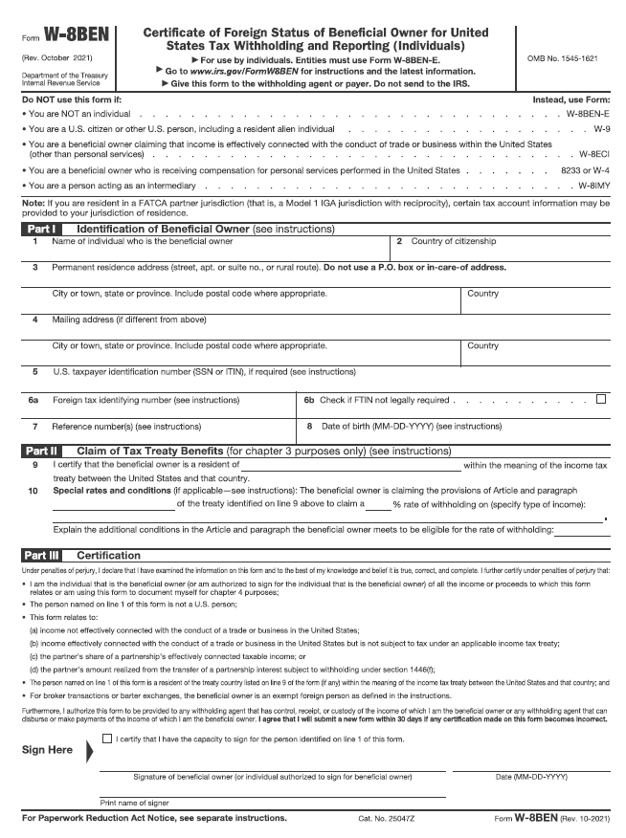
W8: (for Speakers outside of the United States) Return signed form to Speaker Forms

W9: (for Speakers within the United States) Return signed form to Speaker Forms
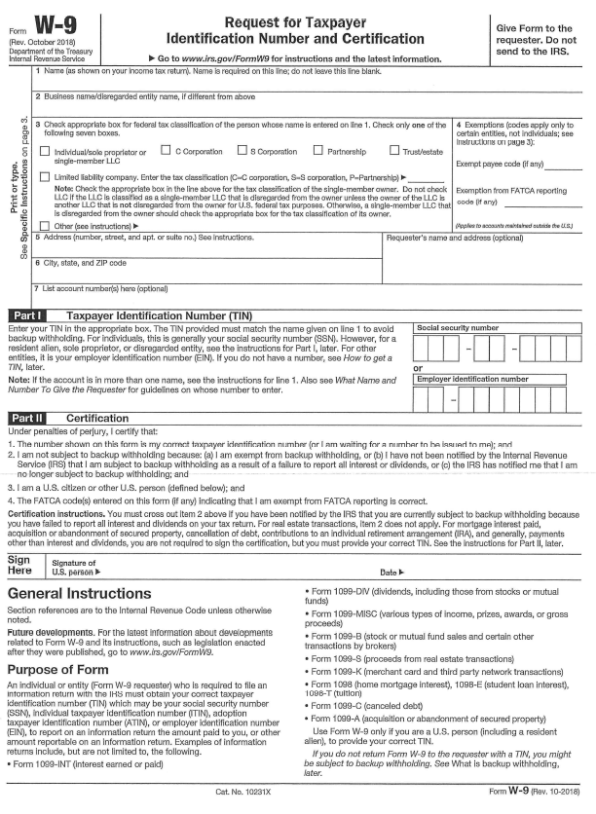

Speaker Honorarium Forms
Complete Online Wire Transfer Form : ICCN 2026 Speaker wire transfer form
Submit the completed W8 or W9 and Wire transfer forms to a secure site here: Confirmed Speaker Payment Details

IFCN LICENSING PERMISSION AGREEMENT AND RELEASE FORM
Submit the completed permission agreement and release form to a secure site here: Speaker Licensing Permission Agreement

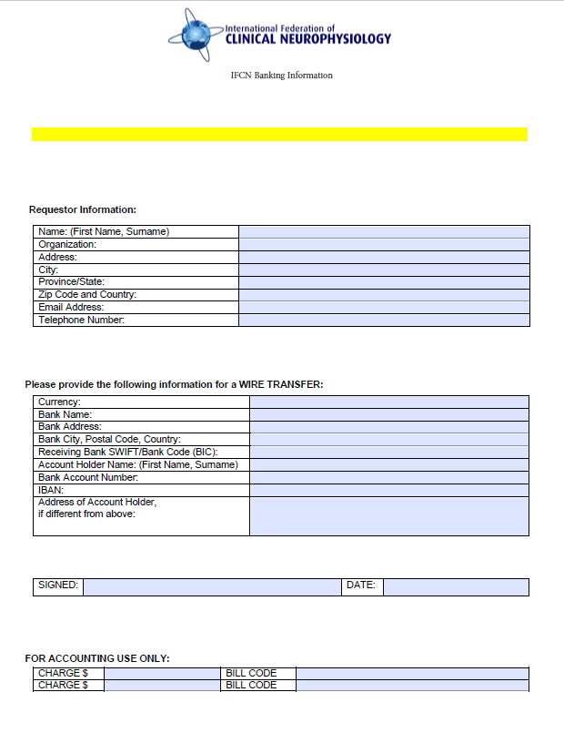
IFCN Banking Wire Transfer Form

